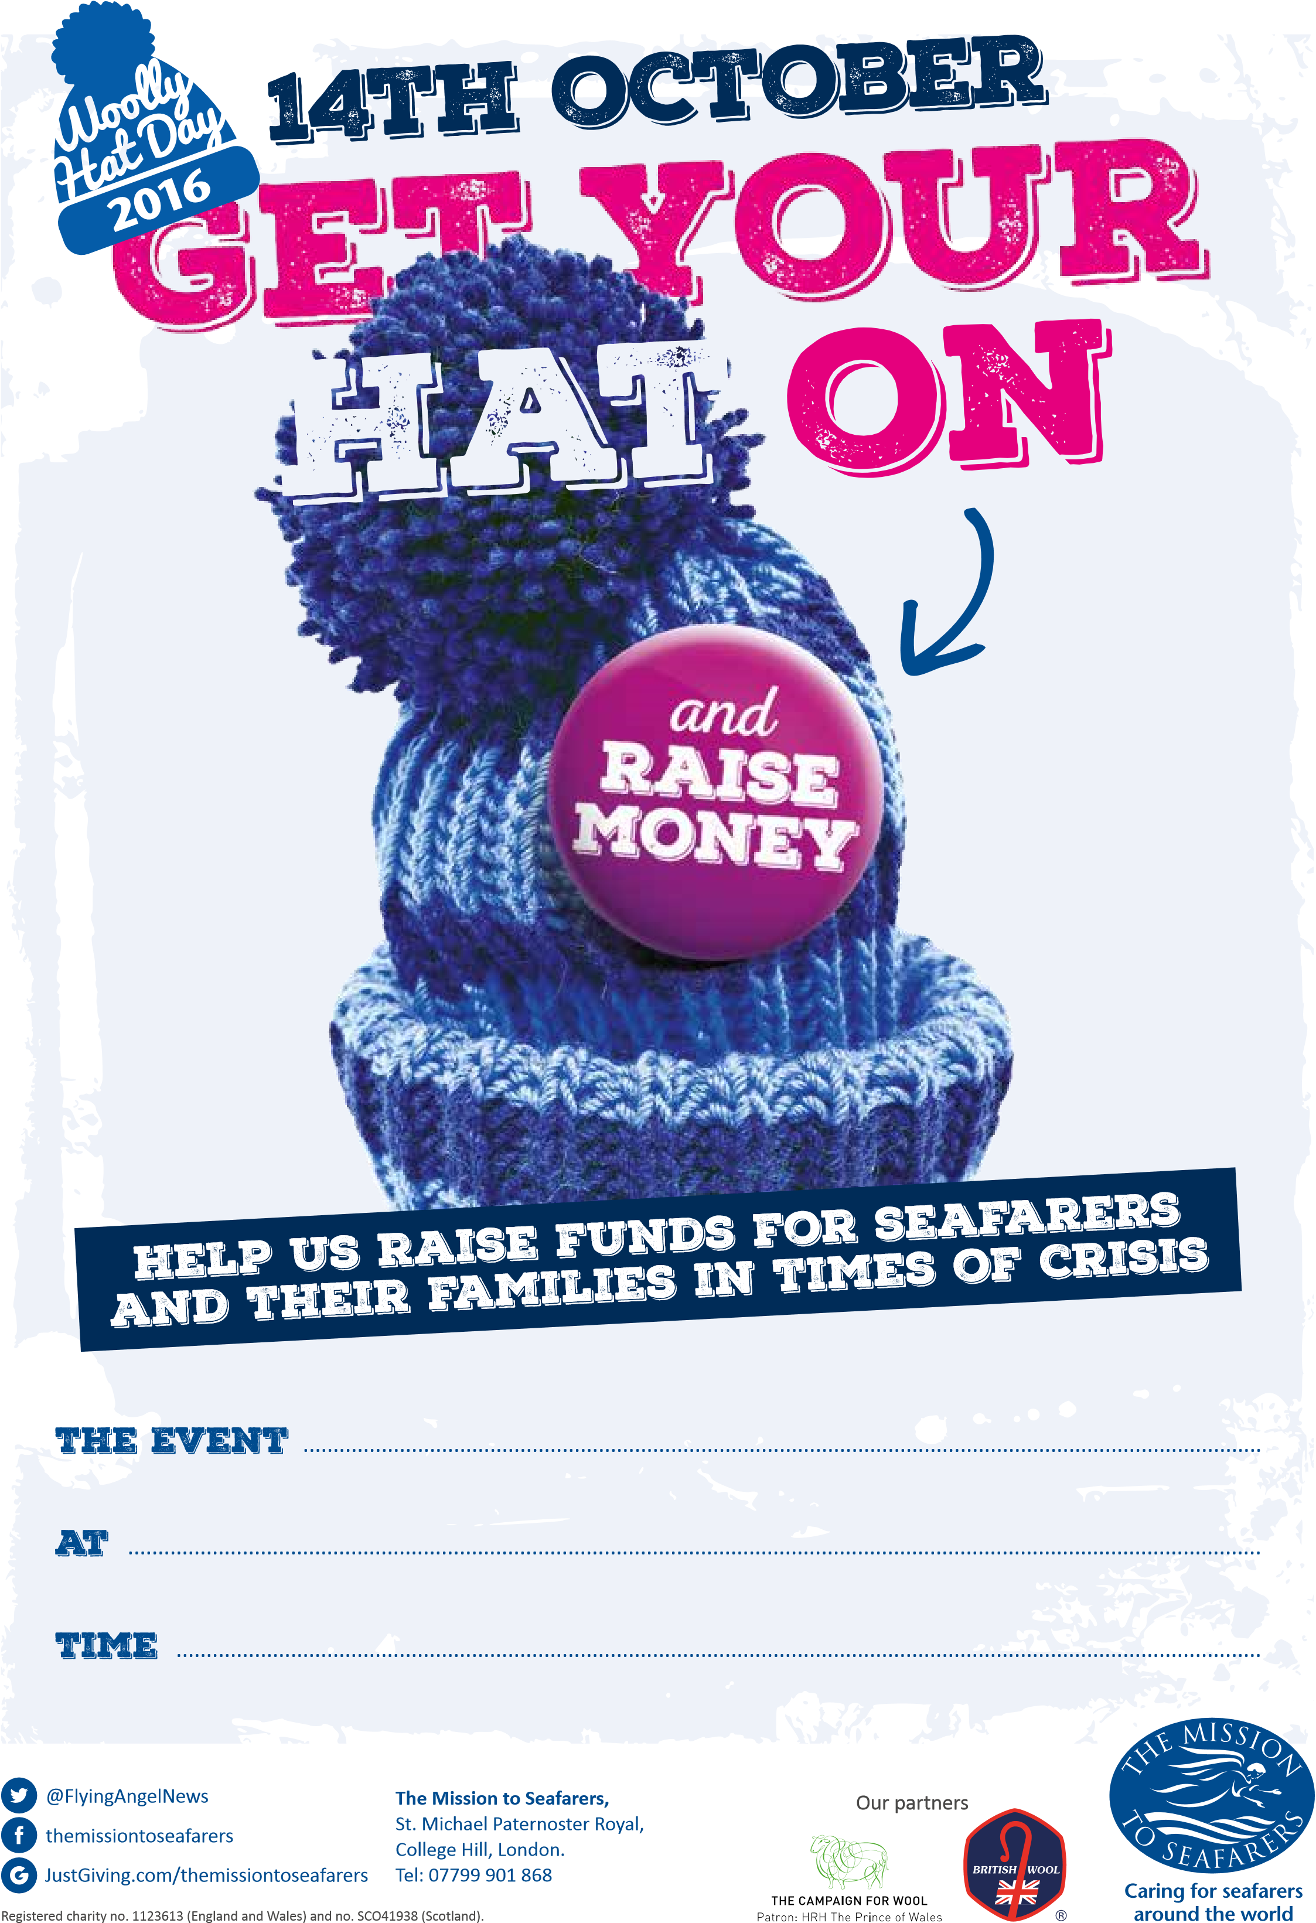
10 am – 12.00 noon

16th OCTOBER 2021

St Nicholas Church, Harwich

16th OCTOBER
2021

